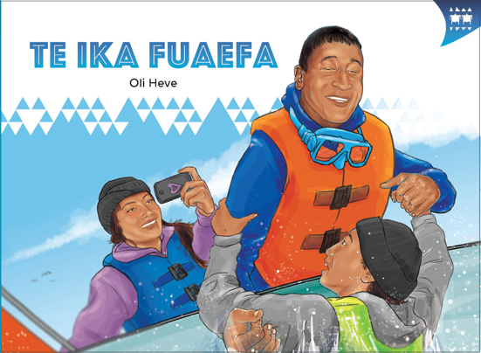
TEACHER SUPPORT MATERIALS TO ACCOMPANY:

Stories to Support the Pacific Learning Languages Series Resource
Muakiga! An Introduction to Gagana Tokelau

Te Ika Fuaefa
by Oli Heve

Overview
These teacher support materials accompany the six storybooks developed especially to support the Learning Languages Series resource Muakiga! An Introduction to Gagana Tokelau. Each story gives students opportunities to extend their language and cultural knowledge and to practise reading the target language of specific units in Muakiga!
These teacher support materials suggest how teachers can use the six storybooks to foster gagana Tokelau learning at levels 1 and 2, particularly in the context of the Muakiga! programme.
The teaching-as-inquiry cycle and the Newton et al. research on intercultural communicative language teaching underpin these teacher support materials. See:
- the effective pedagogy section on page 35 of The New Zealand Curriculum
- the Newton et al.paper.

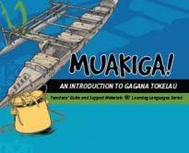
Muakiga! An Introduction to Gagana Tokelau
Muakiga! is a resource in the Learning Languages Series. It provides a language-teaching programme that can be used by teachers, including those who do not speak gagana Tokelau or know how to teach languages. Muakiga! includes:
- twenty units of three lessons each
- a range of language suitable for years 7–10 at levels 1 and 2 of the curriculum
- video and audio support to engage learners and demonstrate how fluent speakers
use the language
- lesson plans that could be linked to opportunities for learners to enjoy reading
gagana Tokelau texts.
You can find Muakiga! online here.

Engaging students with texts
The teacher’s role is to mediate the interactions between the student and the learning materials and enable the student to meet their learning outcomes.

Te Ika Fuaefa
by Oli Heve
This story supports Unit 8: Meakai ma te Meainu (Food and Drink) in Muakiga!

Learning goals
Encourage your students to set one or more of the following learning goals for their work with this storybook. The learning activities support these goals.
I will use gagana Tokelau to:
- read the story and understand it
- read the story aloud with clear pronunciation and reasonable fluency
- recognise and use some words and expressions in different contexts
- write texts with macrons and correct spelling
- talk or write about the story.
I will use English to:
- understand the story when it is read aloud
- talk about the content of the written and visual texts
- give examples of how Tokelau language and culture are organised in particular ways
- make connections with the language(s) and culture(s) I know
- research and present information about Tokelau culture and values in the story
- make connections to my learning in Unit 8 of Muakiga!

Language and Cultural Knowledge strands
The Language and Cultural Knowledge strands at levels 1 and 2 of Learning Languages in The New Zealand Curriculum require students to:
- recognise that the target language and culture are organised in particular ways
- make connections with known languages and cultures.
The language and cultural features of the written and visual texts in the storybook are described here.

(a) Language Knowledge
The language features of the written texts include:
- formulaic expressions used in everyday conversation, for example, Oka lā! / Wow!; Te gali! / Good one!; Io, te manaia kō! / Yeah, it was so cool!
- words transliterated from English, for example, maho / mussel; telefoni / telephone; alaiha / rice; Iēhū / Jesus; paelo / pail (barrel, container)
- relationship terms, for example, afafine / daughter (of a man) ; ataliki / son (of a man); tupuna / grandparents; faimātua / aunt
- numbers and quantities, for example, kua fā hefulu ono / we have forty-six; te lahi o a mā ika na hī / we caught heaps of fish; te vāega / the share
- different forms of the verb, for example, kata / laugh (singular) and faikakata / laugh (plural); faitatala / talk, chat (plural)
- markers which make the meaning more precise, for example, nā tupuna o koulua / grandparents of you both; Kua faikakata uma te tokatolu tēnei. / They all (three of them) laughed.; taku / my (singular) and aku / my (plural)
- onomatopoeia, revealing how languages express sounds differently, for example, PATATŪ! / SPLASH!
- natural or idiomatic use of gagana Tokelau, for example, I taku kikila e lahi atu aku ika. / I probably caught the most fish. The literal English translation reads: In my view is big – indicator of direction from speaker to hearer (aku) – my (plural) fish.

(b) Cultural Knowledge
The cultural features of the written and visual texts include:
- use of words that have cognates in other languages, although the meanings may differ, for example, fānau / children. In te reo Māori, the word whānau is more commonly used to refer to an extended family.
- reference to particular shellfish gathered, for example, mussels (maho), pāua (pāua), and fish caught, for example, kahawai (kauai) and spotty (hipoti). Recreational gathering of shellfish and fishing in New Zealand waters is subject to quotas and measurements set by the New Zealand Government and advertised online by Fisheries New Zealand. At the time of writing, the numbers of shellfish and fish caught in the storybook complied with these regulations.
- use of specialist gear when fishing from a boat in New Zealand waters, for example, wetsuit, goggles, safety jackets, rods, lines, and containers to hold the catch.
- distribution of the catch to family members through an inati process, where the mother divides up the catch and the young people take the shares to their relatives. This action emphasises the fact that, for Tokelau people, fishing is not a recreational activity. It is a purposeful activity for gathering food to feed their families.
- the value of fakaaloalo (respect) expressed through the practice of giving thanks for the food and refreshments by saying a lotu fakafetai (grace) before the meal. Saying this grace also marks the beginning of the meal. Then the sharing of food can begin.
- the values of māopoopo (inclusion) and fakahoa lelei (equity). The young people help catch the food. They help put away the fishing gear and take the catch to the house. They distribute the food to their extended family.
- reference to relatives by their first names, for example, ki a Peato ma Mele / to Peato and Mele. This is a reference to Laki’s grandparents. Meliha addresses her mother as Kia (as on page 10).
- a reference to tautai (expert fishermen). Although Laki is joking, the tautai in Tokelau culture leads the expedition because he is the expert fisherman and has the skills and knowledge to make the fishing expedition successful.

Communication strand
Students learn to apply their language and cultural knowledge in different contexts and situations to communicate effectively for a range of purposes. As they become more effective communicators, students develop the receptive skills of listening, reading, and viewing and the productive skills of speaking, writing, and presenting or performing. These are summarised on the Learning Languages Wallchart.

(a) The New Zealand Curriculum
The achievement objectives in learning languages, levels 1 and 2 are generic.
In selected linguistic and socio-cultural contexts students will:
- receive and produce information
- produce and respond to questions and requests
- show social awareness when interacting with others.

(b) Gagana Tokelau: The Tokelau Language Guidelines
These guidelines offer achievement objectives that are more specific. You could use any of the following level 1 achievement objectives to narrow the focus for your students to help them achieve particular competencies. In selected linguistic and socio-cultural contexts students will:
- recognise and express number, time, and location (1.4)
- express and respond to desires, needs, and preferences (1.7)
- use language, positioning, and movement to show respect (1.8).

(c) Muakiga! An Introduction to Gagana Tokelau
The Unit 8 learning outcomes for students are sharply focused. The following outcomes are relevant to this story. Students will:
- identify some food and drinks
- show social awareness when interacting with others
- communicate interest, enjoyment, and need.

Cross-curricular links
Learners who are working at levels 1 and 2 in gagana Tokelau will be working at higher curriculum levels in other learning areas. Here are two examples of cross-curricular achievement objectives that could be linked to this story when you are planning links across curriculum learning areas.

Social Sciences, Level 3
Students will gain knowledge, skills and experience to:
- understand how people make decisions about access to and use of resources.

Technology, Level 3 (Nature of Technology)
Students will:
- understand how society and environments impact on and are influenced by technology in historical and contemporary contexts and that technological knowledge is validated by successful function.

Values
The story illustrates the values of:
- community and participation for the common good
- respect for themselves and others.
See page 10 in The New Zealand Curriculum.
In addition, students will come to appreciate how the story reflects core Tokelau values of fakaaloalo (respect), māopoopo (inclusion), and vā feāloaki (relating to others). See pages 8–9 in Gagana Tokelau: The Tokelau Language Guidelines.

Effective pedagogy for language teaching
Effective pedagogy research is integrated into these teacher support materials.
The New Zealand Curriculum (pages 34–36) summarises evidence of the kinds of teaching approaches that consistently have an impact on student learning.
Research into second language acquisition pedagogy reviewed in Ellis (2005) establishes ten principles for teacher actions that promote student learning.
Research into intercultural communicative language teaching (Rivers, based on Newton et al. 2010) establishes six principles for a pedagogy that is effective in achieving the outcomes specified in The New Zealand Curriculum.

Language learning activities
Choose or adapt these learning activities to suit your students’ diverse needs and the particular objectives they are to achieve.
Listening comprehension – focus on actions
This activity helps the students to understand the story when it is read aloud. They focus on the actions performed by particular characters in the story.
As you listen to the story, write in the name of the person who completed each action.
1. ________________ counted the mussels.
2. ________________ counted the pāua.
3. ________________ caught a kahawai.
4. ________________ caught a spotty.
5. ________________’s fish was bigger.
6. ________________ fell into the sea.
7. ________________ helped put the fishing gear away.
8. ________________ took the mussels.
9. ________________ took the pāua.
10. _______________ brought the fish.
11. _______________ took the share to Aunty Fetu.
12. _______________ took the share to the grandparents.
13. _______________ said a prayer of thanks for the meal.
14. _______________ said the dinner was yummy.
15. _______________ caught the most fish.
16. _______________ caught the biggest fish.
Hand our copies of this gap activity, one copy per student. Write the names of the characters in the story on the board.
Read the text aloud. As the students listen, they write the name of the person who completed each action in the gap. Repeat the reading so that your students manage to complete their entries. The students check their responses using copies of the storybook or the English translation.
Formulaic expressions
The students recognise particular phrases in context. They use these when they communicate in gagana Tokelau in other contexts.
The students work in pairs. They read the story and make a list of ten formulaic expressions that they can use when speaking gagana Tokelau. If needed, hand out copies of the English translation for them to refer to as they work on this task. Some examples of formulaic expressions are:
- Ē ā lā koe i ei? / How about that, eh?
- Heā kō? / What was that?
- Io, e hako. / Yes, it does. (an expression of agreement)
Compile a list of suitable expressions. Write these on charts for the classroom wall. One chart has the expressions in gagana Tokelau. Another chart has the same expressions in English. Challenge the students to use these expressions as they work on tasks in the classroom. In this way, they develop their skills in communicating in gagana Tokelau.
Reading aloud – focus on pronunciation
The students improve their pronunciation and reading fluency in gagana Tokelau.
The students work in groups to read the story aloud as a role-play. Give them time to rehearse their role-plays before they present them to the class, to enable them to build fluency in the delivery of their lines. You may wish to have a gagana Tokelau speaker involved with this activity so that your students can benefit from feedback, and work to improve the quality of their pronunciation.
Charades
This activity reinforces the students’ vocabulary knowledge, helping them to make direct links between the words and actions.
Make sets of cards with a phrase in gagana Tokelau on each card that describes an action, for example, puke ni ata (take some photos). The students work in small groups. Each group spreads out the cards, face up, in the centre of the group. One person mimes an action on one of the cards. The first person to pick up the card that matches the mimed action gets a point. The person with the most points wins.

Food for the table
The students recognise that the target language and target culture are organised in particular ways as they explore how people make decisions about access to and use of resources. They make connections with their own language(s) and culture(s).
Fishing is important to Tokelau people. The students research:
- fishing in Tokelau, for example, net fishing, reef fishing, open sea fishing, and the kinds of fish and shellfish that are commonly caught to provide food for the table. What practices are used for sustainable fishing? A useful open access online resource is Echoes at Fishermen’s Rock: Traditional Tokelau Fishing.
- fishing by Tokelau people in New Zealand, for example, shore fishing, open sea fishing, and the kinds of fish and shellfish that are commonly caught to provide food for the table. What practices are used for sustainable fishing?
The students contribute to wall charts, illustrating and naming the fish and shellfish commonly eaten in (a) Tokelau and (b) New Zealand. Discuss with them what they discovered about sustainable fishing practices in Tokelau and in New Zealand.
Technologies used in fishing
This activity helps the students to understand how society and environments impact on and are influenced by technology in historical and contemporary contexts.
Play the song “Te Galu kā Tū Nei” to set the scene. This song is about paddlers who steer their canoe through the reef. The song is in the print and CD resources Fātuga Faka-Tokelau: Tokelauan Songs [item 31047] and Songs to Celebrate Pasifika Languages and Cultures: Songs and Music to Support the Pasifika Learning Languages Series for Years 7 – 10 (Wellington: Ministry of Education, 2010).
The students work in pairs or groups to explore the differences between the technologies used for fishing in Tokelau and in New Zealand, for example, kinds of boats; how the boats are powered; what people wear when fishing; and the kind of equipment they use to catch the fish and store their catch. Divide up the topics. The students make a wall chart (with written and visual texts) for others to view. They present their information to others in the class. Display these wall charts in a suitable place in your school.
As your students present their research, ask them what comparisons and connections they can make with practices in their own cultures.
Writing
The students prepare written texts using macrons and correct spelling. They construct meaning through writing in order to communicate about people, places, and things.
The students work in groups of three or four. Each group composes a story in gagana Tokelau about fishing. They use the text in the storybook as a basis for their stories. When they complete their stories, they hand them to another group to read.

Each group reads the story they are given, and gives feedback to the writers about how well they understand the story. The feedback includes what helped them to understand the story and what hindered their understanding. This feedback will give you useful insights into the reading strategies the students are using.
Showing social awareness
The students use language, positioning, and movement to show respect. They show social awareness when interacting with others.
The students work in pairs or groups to find examples of fakaaloalo (respect) in the story. Each group compiles a list of examples. The groups take turns to share their examples with the other groups. As they give their examples, write these on the board as a checklist. Discuss the inati philosophy and have the students comment on the values it entails, and to what extent they are represented in the story.
The students work in groups to prepare a role-play based on the story. They use appropriate positioning and movement to show respect. Emphasise the difference in focus between learning activity 3 in these support materials and this task.
Use a video recording of their role-plays as a stimulus for discussion and to provide feedback on their performances. Use the criteria for “controlled production” on pages 239–240 in Unit 9 of Muakiga!
Responding to questions
The students produce information by responding to questions.
Set the scene. Each student has been out fishing and has caught a big fish. When they come to shore, they are interviewed about their catch. The interviewer asks them a set of questions and they give replies. The students use expressions from the storybook along with those they learned in Units 1–8 of Muakiga! to prepare their responses.
As you are the teacher, take the role of the interviewer, or select a competent gagana Tokelau speaker in your class to perform this role. Prepare the questions so that your students know what to expect. The questions include greetings, asking for name, age, address, who was with them on the boat, what other catch there was, who caught the biggest fish, what kind of fish it was, and their feelings about the catch.
Adapting text
The students adapt particular phrases and use them in different contexts to reinforce their learning.
The students make up a story about something big they have or have done. They find three sentences from the storybook and from Units 1–8 of Muakiga! to use to tell their story. They could use themes such as:
- I have the biggest family.
- I ate the biggest fish.
- I made the biggest sandwich.
When the students are ready, have a round robin, where the students take turns to tell their story round the class.
For an extra challenge, tell the students that the rule is now “no repetition”. When one student mentions an item, then no one else can use it. The students have to listen carefully to others and be ready to change their item if it has already been used.
Enjoying food
This activity reinforces the achievement objectives for Unit 8, enabling the students to:
- identify some food and drinks
- show social awareness when interacting with others
- communicate interest, enjoyment, and need.
The focus for this activity is pages 8 and 9 of the storybook, and the vocabulary and expressions the students have been learning in Unit 8. Working in groups, the students make up a scenario that is different in detail from the one described in the storybook. The scenario involves family members, a description of dinner on the table, the young people’s involvement, and comments about the food.
The students take time to develop their scenarios and rehearse them. They present their role-plays to the class and receive feedback on how well class members have been able to understand them.
Reflecting on their learning
You can help the students to reflect on their learning, and also on how they learn. Students could share these reflections with another student, with a small group of students, or with the whole class. As a prompt, ask the students questions such as:
- What strategies and activities helped you to understand the story?
- What strategies and activities helped you to remember the new language?
- How can you use the new language in other contexts?
- Can you identify aspects of new learning about Tokelau culture?
- How have you improved your use of gagana Tokelau?
For example, a student might say:
“I can now communicate something about fishing in gagana Tokelau. Writing about fishing, and answering questions about it, helped me to remember new language. I can also talk about differences between fishing in New Zealand and in Tokelau, the technologies used, and sustainable practices.”

English version of the story
In English, this story by Oli Heve is:

The Big Fish
page 3
“How many mussels do we have now, Laki?” Hāvini asked his son. Hāvini and his children,
Laki and Meliha, were fishing.
“Hold on! One, two, three … we have forty-six. That’s plenty,” Laki replied.
“We have ten pāua,” said Meliha to her father.
“And we have heaps of fish. The pail is full,” Laki said.
Suddenly, a fish took Meliha’s line again.
“Good one! You go, girl!” Hāvini said to Meliha. They all laughed.
When Meliha pulled the fish out of the water, they saw it was a kahawai. It was huge! Wow!
Laki caught a fish as well.
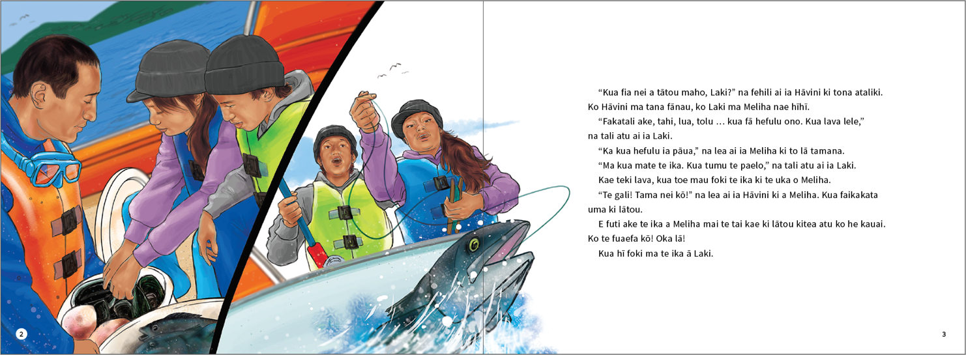
page 4
“Hey! How’s that? It’s a huge fish! Meliha, look how big the fish is. It’s bigger than your fish,”
said Laki.
“You’re right. It must be a huge fish,” Meliha said.
Hāvini helped Laki pull the line in.
Meliha remembered her cellphone. She took some photos of Laki catching his “huge” fish.
As they pulled the fish in, they saw it was a big spotty. Meliha helped Hāvini and Laki bring the
fish into the boat.
“How about that, eh?” Laki was singing and dancing around in the dinghy.
Meliha and her father were laughing at Laki all this time. The boat was now rocking.
SPLASH! What was that?
The above page:
Text and illustrations copyright © Crown
Laki has fallen into the sea. Meliha and their father laughed some more. Hāvini pulled Laki
back into the dinghy.
“Are you hurt Laki?” Meliha asked.
“How can an ‘expert fisherman’ be hurt?” Laki answered.
Hāvini and his children all laughed.
page 7
“Come on, let’s get back to shore. We have enough catch for the week,” Dad said to his children.
When they arrived home, the young people helped their dad put the fishing gear away.
“Laki, you take the mussels. Meliha, you take the pāua. I will bring the fish,” their dad said.
“Leave them behind the house. Then go and help your mum prepare our dinner.”
“Come here please, you two,” said their mum, Kia. “Meliha, put ten mussels and three pāua into that bowl. Put these five fish in as well. Take them for Aunty Fetu,” Kia said. “Laki, you take this share to your grandparents, Peato and Mele.”
page 8
Meliha and Laki returned home. “Mmm, the food smells yummy!” Laki said to his sister.
“Yes, it does. I’m so hungry,” said Meliha.
Dinner was cooked. It was roast chicken, boiled fish from the day’s catch, and rice. There were also raw mussels and pāua on the table.
“Meliha, Laki, come! Tell your dad we are ready for dinner,” Kia said.
“Meliha, can you say grace?” Hāvini asked his daughter.
“Jesus, thank you for your love, the food you provide, together with the drink you have given us to nourish and sustain us. Jesus, thank you for your love. Amen,” prayed Meliha.
“Dinner is so yummy, thank you,” Laki said to their mum.
“Yes, it is. I’m very hungry too,” said Hāvini.
They all ate hungrily and talked excitedly about the fishing.
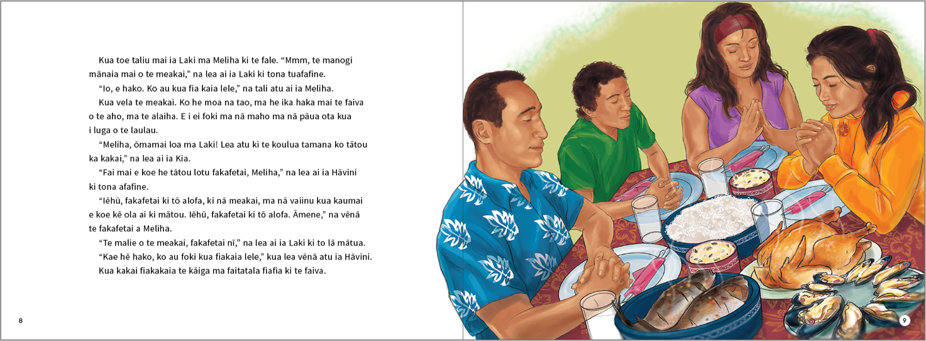
The above page:
Text and illustration copyright © Crown
The above page:
Text and illustration copyright © Crown
The above page:
Text and illustration copyright © Crown
page 11
“Kia, I took some photos on the cellphone. Here are some photos of the biggest fish we caught,” Meliha said to her mum.
“Too right. We caught heaps of fish. I probably caught the most fish,” Laki said to Meliha.
“Yeah, it was so cool! But I think I caught the most fish. Look at all the fish I caught,” said Meliha to their mum. Then Meliha showed Kia some more photos.
“But I caught the biggest fish,” Laki said to Meliha and Kia.
“That’s huge,” Kia said.
“It sure is!” laughed Laki.
“What happened?” Kia asked her daughter.
“That’s the biggest ‘fish’ we caught. Hāvini caught it,” Meliha said to their mother. Meliha and her mother were laughing.
page 12
“Why are you all laughing?” Laki asked. “Show me!” Laki walked over to his mum, to look at the photos. He saw a photo of himself. His father was pulling him back into the dinghy.
“That’s the biggest ‘fish’ we caught. Hāvini caught it,” Meliha told their mum. Hāvini and Kia laughed.
“Who caught the biggest ‘fish’, Laki?” asked Meliha, laughing.
“Whatever!” Laki said.

ISBN 978-1-77669-690-1 (WORD)
ISBN 978-1-77669-691-8 (PDF)
The above page:
Text and illustration copyright © Crown

Newton, J., Yates, E., Shearn, S., and Nowitzki, W. (2009). Intercultural Communicative Language Teaching: Implications for Effective Teaching and Learning. Wellington: Ministry of Education.

