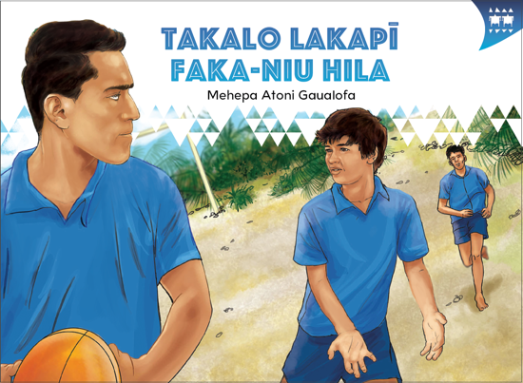
TEACHER SUPPORT MATERIALS TO ACCOMPANY:

Stories to Support the Pacific Learning Languages Series Resource
Muakiga! An Introduction to Gagana Tokelau

Takalo Lakapī Faka-Niu Hila
by Mehepa Atoni Gaualofa

Overview
These teacher support materials accompany the six storybooks developed especially to support the Learning Languages Series resource Muakiga! An Introduction to Gagana Tokelau. Each story gives students opportunities to extend their language and cultural knowledge and to practise reading the target language of specific units in Muakiga!
These teacher support materials suggest how teachers can use the six storybooks to foster gagana Tokelau learning at levels 1 and 2, particularly in the context of the Muakiga! programme.
The teaching-as-inquiry cycle and the Newton et al. research on intercultural communicative language teaching underpin these teacher support materials. See:
- the effective pedagogy section on page 35 of The New Zealand Curriculum
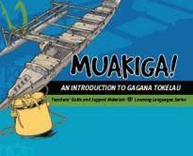
- the Newton et al.paper.

Muakiga! An Introduction to Gagana Tokelau
Muakiga! is a resource in the Learning Languages Series. It provides a language-teaching programme that can be used by teachers, including those who do not speak gagana Tokelau or know how to teach languages. Muakiga! includes:
- twenty units of three lessons each
- a range of language suitable for years 7–10 at levels 1 and 2 of the curriculum
- video and audio support to engage learners and demonstrate how fluent speakers
use the language
- lesson plans that could be linked to opportunities for learners to enjoy reading
gagana Tokelau texts.
You can find Muakiga! online here.

Engaging students with texts
The teacher’s role is to mediate the interactions between the student and the learning materials and enable the student to meet their learning outcomes.

Takalo Lakapī Faka-Niu Hila
by Mehepa Atoni Gaualofa
This story supports Unit 5: Tākaloga (Sports and Games) in Muakiga!

Learning goals
Encourage your students to set one or more of the following learning goals for their work with this storybook. The learning activities support these goals.
I will use gagana Tokelau to:
- read the story and understand it
- read the story aloud with clear pronunciation and reasonable fluency
- recognise and use some words and expressions in different contexts
- write texts with macrons and correct spelling
- talk or write about the story.
I will use English to:
- understand the story when it is read aloud
- talk about the content of the written and visual texts
- give examples of how Tokelau language and culture are organised in particular ways
- make connections with the language(s) and culture(s) I know
- research and present information about Tokelau culture and values in the story
- make connections with my learning in Unit 5 of Muakiga!

Language and Cultural Knowledge strands
The Language and Cultural Knowledge strands at levels 1 and 2 of Learning Languages in The New Zealand Curriculum require students to:
- recognise that the target language and culture are organised in particular ways
- make connections with known languages and cultures.
The language and cultural features of the written and visual texts in the storybook are described here.

(a) Language Knowledge
The language features of the written texts include:
- the choice not to use the word motu (island), and to use the word fenua (land), which reinforces the emotional attachment of the people to the land, and their ownership of it. Fenua is frequently used in written texts with the meaning of “country” or “nation”.
- phrases to express location, for example, i te fenua ko Ātafu i Tokelau / on the island of Ātafu in Tokelau; i lotofale / inside the house
- phrases to express time, for example, i te taimi nei / now; i tē tahi tāeao / one morning (tē tahi because the reference is to time not people)
- formulaic expressions, for example, io lā / OK; ma au foki / same as me; Ke manuia tō ahō. / Have a nice day.
- different verb forms, for example, takalo / play (singular) and tākakalo / play (plural)
- words of special cultural significance, for example, malae lakapī / rugby field, where malae has the meaning of an open space for recreation of a particular kind. In te reo Māori, however, the term marae is restricted to a communal or sacred place that serves religious and social purposes for the people who belong there.
- descriptions, for example, Te fuaefa o le malae lakapī. / The rugby field is huge.; Nae matafakanoanoa ki lāua. / They looked sad.

(b) Cultural Knowledge
The cultural features of the written and visual texts include:
- reference to Ātafu as one of the three atolls that constitute Tokelau. The others are Nukunonu and Fakaofo. See Unit 1, Muakiga! for more information on Tokelau.
- the movement of people between Tokelau and New Zealand. Many settle in New Zealand permanently. Toni lives with his grandparents on Ātafu before joining his parents in New Zealand to continue his education. His grandparents come to New Zealand to visit family after Toni has settled in his new school.
- the value of fakaaloalo (respect). The story shows the cultural practice of Toni being raised by his grandparents. The oldest child may be given to their grandparents to raise as an expression of love and respect for their wisdom and knowledge. This story shows the important role that grandparents have in their grandchildren’s lives.
- the values of fakaaloalo (respect) and alofa (compassion) seen in the special relationship that Toni has with his grandfather as the eldest grandson. The metaphor of the tokotoko (walking stick) portrays the grandfather’s dependence on his eldest grandson. It explains the grandfather’s sadness when Toni leaves for New Zealand and his joy at seeing Toni succeed at his new school.
- reference to the Lalo Pua, which literally means “Under the Pua”. The pua is the biggest tree on Ātafu. This place is culturally and socially significant to the local people as a traditional meeting place for men. They gather there to carve or to chat, sharing their knowledge about such things as carving, fishing, and politics.
- illustrations that compare styles of housing in Tokelau and in New Zealand. Tokelau houses have communal living areas where there is little privacy. The shower or bathing area is outside and may be in public view. The houses are traditionally a single cell area, with a space for cooking and another space where the family sits in the daytime and sleeps at night-time. Some houses may have smaller rooms for sleeping.
- a comparison between how rugby is played in Tokelau and in New Zealand. In Tokelau, rugby is commonly played barefoot, with any kind of ball, on an unmarked field that has a pebbled, stony, or coral surface. There are no seats or stands for spectators and the field is smaller than rugby fields in New Zealand.

Communication strand
Students learn to apply their language and cultural knowledge in different contexts and situations to communicate effectively for a range of purposes. As they become more effective communicators, students develop the receptive skills of listening, reading, and viewing and the productive skills of speaking, writing, and presenting or performing. These are summarised on the Learning Languages Wallchart.

(a) The New Zealand Curriculum
The achievement objectives in learning languages, levels 1 and 2 are generic.
In selected linguistic and socio-cultural contexts students will:
- receive and produce information
- produce and respond to questions and requests
- show social awareness when interacting with others.

(b) Gagana Tokelau: The Tokelau Language Guidelines
These guidelines offer achievement objectives that are more specific. You could use any of the following level 1 achievement objectives to narrow the focus for your students to help them achieve particular competencies. In selected linguistic and socio-cultural contexts students will:
- give and respond to greetings, farewells, and introductions (1.1)
- give and respond to personal information (1.2)
- recognise and express number, time, and location (1.4)
- recognise and express size and colour (1.5).

(c) Muakiga! An Introduction to Gagana Tokelau
The Unit 5 learning outcomes for students are sharply focused. Students will:
- identify some sports and games
- communicate about the sports they play
- talk about the sports their family members play
- ask about and discuss sports preferences.

Cross-curricular links
Learners who are working at levels 1 and 2 in gagana Tokelau will be working at higher curriculum levels in other learning areas. Here are two examples of cross-curricular achievement objectives that could be linked to this story when you are planning links across curriculum learning areas.

Technology Level 3 (Nature of Technology)
Students will:
- understand how society and environments impact on and are influenced by technology in historical and contemporary contexts and that technological knowledge is validated by successful function.

Social Sciences, Level 3
Students will gain knowledge, skills, and experience to:
- understand how people view and use places differently.

Values
The story illustrates the values of:
- community and participation for the common good
- respect for themselves and others.
See page 10 in The New Zealand Curriculum.
In addition, students will come to appreciate how the story reflects core Tokelau values of fakaaloalo (respect), māopoopo (inclusion), and vā feāloaki (relating to others). See pages 8–9 in Gagana Tokelau: The Tokelau Language Guidelines.

Effective pedagogy for language teaching
Effective pedagogy research is integrated into these teacher support materials.
The New Zealand Curriculum (pages 34–36) summarises evidence of the kinds of teaching approaches that consistently have an impact on student learning.
Research into second language acquisition pedagogy reviewed in Ellis (2005) establishes ten principles for teacher actions that promote student learning.
Research into intercultural communicative language teaching (Rivers, based on Newton et al. 2010) establishes six principles for a pedagogy that is effective in achieving the outcomes specified in The New Zealand Curriculum.

Language learning activities
Choose or adapt these learning activities to suit your students’ diverse needs and the particular objectives they are to achieve.
Listening comprehension – focus on meaning
This cloze activity is based on page 4 of the storybook. The students make meaning from what they hear, and reinforce their knowledge of words used in particular contexts.
“Goodbye, ________,” said Lopa. “_______ _______ _______ _______!”
Lopa met up with Toni on their way to_______.
“Let’s play _______with the ______ at break,” _____ said to _______.
“I _____ ______ ________ __________,” said Lopa.
“What about a _____ _______ then?” asked Toni.
“______! It’s my ________ sport,” Lopa said.
“______ _______ _______ ,” said Toni.
Read the passage aloud, or arrange for a speaker of gagana Tokelau to read it. As they listen, the students write the missing information in the gaps, in English. Repeat the reading so that your students manage to complete their entries. The students check their responses using the storybook or English translation.
Dictation
The students recognise particular sound-spelling combinations and learn to write texts with appropriate use of macrons and correct spelling.
Try the following sentences. Read them out one at a time. Say each sentence twice, giving the students time to write the sentence in their books.

- Kua fofou lele ke fakailoa ki tona kāiga te tala fiafia.
- Ko koe lā kua i te kau lakapī a te ākoga.
- Kua matuā fiafia lele ia Toni.
- Ko to mātou malae lakapī i Ātafu he tamā malae lele.
- I te mālōlōga pukupuku kua fano ia Toni ki fafo ma ana uō fou.
Project the sentences, or hand out copies of the storybooks for the students to find the sentences, so that they can correct their own work. Ask them how well they managed the task. Tell them to write a note to themselves about what they need to improve the next time they write in gagana Tokelau.
Reading aloud
This activity has a focus on pronunciation and reading fluency in gagana Tokelau.
The students work in groups. They take turns to read the story aloud. Group members give feedback to the readers, congratulating them by saying Lelei or Mālō lava, or suggesting they try again to get the pronunciation right. This helps them to monitor the development of their pronunciation of gagana Tokelau. You may wish to invite a gagana Tokelau speaker to help develop your students’ pronunciation skills.
Sequencing
The students read the story (or parts of it) and demonstrate their understanding. To encourage rapid reading, place a time limit on their task.
Photocopy (or retype) sentences from pages 7 and 8 onto card. Cut the card so that each piece has one sentence. Hand out the sets of sentences, one to each pair or group of students. The students arrange the sentences in sequence, without referring to the storybook. Let the students use the storybook to check their work, or read the pages aloud as students check their sequences.
Patterns of language
The students recognise and use particular phrases in different contexts to reinforce their learning. They develop their understanding of how gagana Tokelau is organised in particular ways.
As a class, focus on particular words or phrases used in the story. For example, students look at the language used to describe people and places, and choose sentences like these:
- Kua matafakanoanoa ki lāua. / They looked sad.
- Ko te koutou malae lakapī foki he malae mutia! / And your rugby field has grass!
The students select the patterns they can use. They write these sentences in their books, so that they can use them in other contexts, or adapt them to suit, for example, Na mālō tana kau. / Her team won.
Language and cultural knowledge discussion
The students research, explore, and present information on aspects of agānuku Tokelau mentioned in the story and the values they express. The students develop their understanding of how people view and use places differently.
Explore the following discussion points with your students. They work in pairs, or groups, and then share their findings with the rest of the class.
Focus areas:
- Describe what the illustrations show, and make connections between the illustrations and the written text.
- Compare and contrast aspects of playing rugby in the two countries.
- Explore particular language and cultural practices, for example:
formulaic expressions used in the story
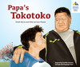
clothes people wear in the illustrations
a description of the Lalo Pua and its cultural significance
the relationship between the eldest grandson and grandfather.
The information in the story Ko te Tokotoko o Toku Tupuna / Papa's Tokotoko [item no. 16274] is relevant to this story.
Poster presentations
The students deepen their understanding of how Tokelau culture is organised in particular ways and make connections with the cultures they know.
The students work in pairs or groups, choosing a particular aspect of agānuku Tokelau to research. They organise their information on a poster with written and visual texts. When they present their poster, each group member also makes a connection with a related aspect of their own culture. Display the posters on the classroom wall or in a suitable place within your school.
Role-plays – spoken communication
This task reinforces the specific learning outcomes of Unit 5 in Muakiga! The students process vocabulary and language structures, develop fluency in speaking, and adapt language to suit their own communicative purposes. They also develop their capability to:
- receive and produce information
- show social awareness when interacting with others.
The students work in groups to prepare role-plays using the storybook content to guide their scripts. They rehearse their role-plays before they present them to the class, so that they can say their lines confidently and fluently.
Telling the story
The students produce information by telling the story to others.
The students, individually, give a short spoken presentation to their group or to the class. They retell the story in about ten sentences. They tell the story from the point of view of Toni or Lopa.
The students prepare their talk. They practise it until they are reasonably fluent. They may use notes as a prompt.

Record these talks. Play the recording so that students can self-monitor their performances as well as receive others’ feedback about the improvements they need to make. This feedback may include:
- comment on how well they can be heard (audibility)
- comment on how well they can be understood (pronunciation, stress)
- comment on how well the story makes sense (logical sequence of actions)
- comment on how well the story is presented (fluency, lack of hesitation, not looking at notes).
Technologies for sports
The students develop their understanding of how society and environments impact on and are influenced by technology in historical and contemporary contexts.
The story shows contrasts between rugby grounds in Tokelau and in New Zealand. Facilitate a discussion with your students, or set research questions, about how the use of locally available materials influences the development of particular games and sports in New Zealand and Tokelau settings. The students can explore, for example, the use of shells in the Tokelau game tiuga (see
Unit 5, Muakiga!), or stones in the Māori game mu torere.
Reflecting on their learning
Help the students to reflect on their learning, and also on how they learn. Students could share these reflections with another student, with a small group of students, or with the whole class. As a prompt, ask the students questions such as:
- What strategies or activities helped you to understand the story?
- What strategies or activities helped you to remember the new language?
- How can you use the new language in other contexts?
- Can you identify aspects of new learning about Tokelau culture?
- How have you improved your use of gagana Tokelau?
For example, a student might say:
“I can now tell the story about Toni who came to New Zealand from Tokelau and learned how to play rugby the New Zealand way. Telling the story helped me to remember new language. I learned about the special relationship Toni has with his grandfather.”

English version of the story
In English, this story by Mehepa Atoni Gaualofa is:

Playing Rugby the New Zealand Way
page 2
Toni lived on the island of Ātafu in Tokelau. He lived with his grandparents, Tenise and Taofi, and his cousin, Lopa. Toni was fourteen years old. He was the eldest grandchild. Lopa was eleven years old. One morning, Toni was in the kitchen preparing the lunches for himself and Lopa to take to school. Lopa was playing with a rugby ball inside the house.
page 3
“Toni, Papa wants to go to the Lalo Pua now,” called Lopa.
“Toni, come and take your grandpa to the Lalo Pua now, before you go to school,” said his grandma.
“Since I’m preparing the lunches, Lopa, would you please take Tenise to the Lalo Pua,” said Toni.
“OK, but you are Papa's tokotoko. It’s really your job,” Lopa replied.
page 4
“Goodbye, Grandpa,” said Lopa. “Have a nice day!”
Lopa met up with Toni on their way to school. “Let’s play cricket with the boys at break,”
Toni said to Lopa.
“I don’t like playing cricket,” said Lopa.
“What about a rugby game then?” asked Toni.
“Yes! It’s my favourite sport,” Lopa said.
“Same as me,” said Toni.
page 5
During the break, Toni and Lopa played rugby with the other boys. Toni played very well. But the other boys played well too.
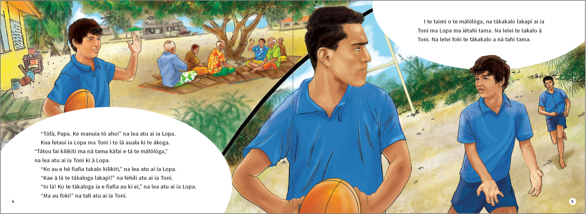
The above page:
Text and illustrations copyright © Crown
The above page:
Text and illustrations copyright © Crown
page 6
Toni and Lopa arrived home from school.
“My team won the rugby game,” Toni told his grandparents.
His grandparents did not look happy. They looked sad.
“Toni,” said his grandma. “It’s time for you to go to New Zealand.”
“Yes,” said his grandpa. “You can play rugby in New Zealand.”
Toni went to his new school in New Zealand.
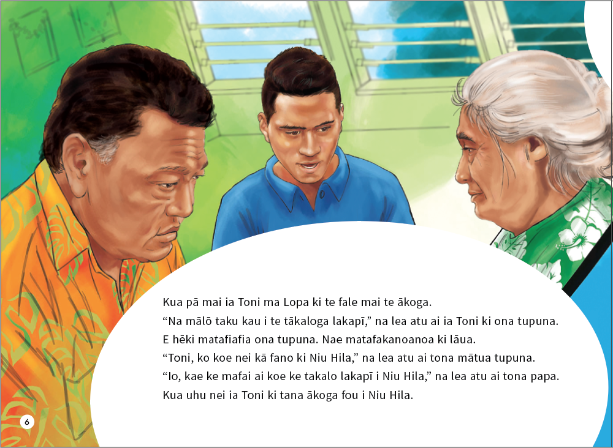
page 7
“Hello,” he said to the other boys. “My name’s Toni. I come from Tokelau. I’m fourteen years old.”
“Hello, Toni. My name’s Oliver,” said one boy.
“Hi, Toni, our names are Anthony and Tamati,” said the other boys.
“Welcome to our school,” they all said.
page 8
During the break, Toni went outside with his new friends.
“What sports do you like to play, Toni?” asked Oliver.
“I like lots, but my favourite is rugby,” Toni answered.
“Awesome! Rugby is our favourite sport too,” said his new friends.
The above page:
Text and illustration copyright © Crown
page 9
“Wow! The rugby field is huge,” said Toni. “Our rugby field on Ātafu is very small. And your rugby field has grass!” Toni said. “And the goal posts are far away!” he added.
Toni played rugby with his new friends. His friends ran fast. They played rugby very well.
page 10
Every day at school, Toni played rugby with his new friends. Every day, he played better.
“You play well,” said his friends. “You are now playing rugby the New Zealand way.”
page 11
One Saturday, Toni went to watch his school rugby team play.
“Toni, Tamati is not here. Come and play with us,” called Oliver.
Toni played very well. He scored a try.
“Congratulations, Toni!” the coach said. “You are now in the school ruby team.”
Toni was very happy.
page 12
Toni went home. He wanted to tell his family the news. His grandparents and Lopa had arrived
from Ātafu.
“Hello,” said Toni. “I’m on the school rugby team. I can now play rugby the New Zealand way!”
“Awesome, Toni!” said Lopa. “You’re a great New Zealand rugby player!”
His grandma smiled. “Well done, Toni,” she said.
His grandpa smiled. “Take me to your next game, Toni,” his grandpa said. “It’s time to support you.”
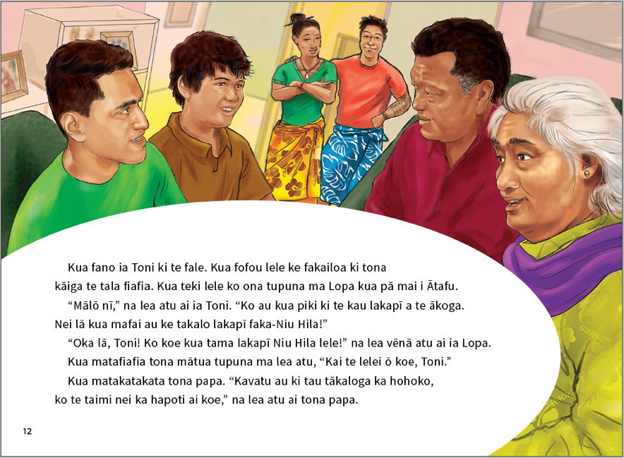

ISBN 978-1-77669-686-4 (WORD)
ISBN 978-1-77669-687-1 (PDF)
The above page:
Text and illustration copyright © Crown

Newton, J., Yates, E., Shearn, S., and Nowitzki, W. (2009). Intercultural Communicative Language Teaching: Implications for Effective Teaching and Learning. Wellington: Ministry of Education.

