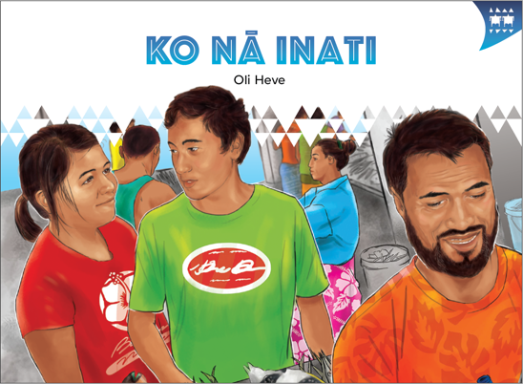
TEACHER SUPPORT MATERIALS TO ACCOMPANY:

Stories to Support the Pacific Learning Languages Series Resource
Muakiga! An Introduction to Gagana Tokelau

Ko nā Inati
by Oli Heve

Overview
These teacher support materials accompany the six storybooks developed especially to support the Learning Languages Series resource Muakiga! An Introduction to Gagana Tokelau. Each story gives students opportunities to extend their language and cultural knowledge and to practise reading the target language of specific units in Muakiga!
These teacher support materials suggest how teachers can use the six storybooks to foster gagana Tokelau learning at levels 1 and 2, particularly in the context of the Muakiga! programme.
The teaching-as-inquiry cycle and the Newton et al. research on intercultural communicative language teaching underpin these teacher support materials. See:
- the effective pedagogy section on page 35 of The New Zealand Curriculum
- the Newton et al.paper.

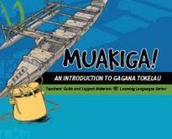
Muakiga! An Introduction to Gagana Tokelau
Muakiga! is a resource in the Learning Languages Series. It provides a language-teaching programme that can be used by teachers, including those who do not speak gagana Tokelau or know how to teach languages. Muakiga! includes:
- twenty units of three lessons each
- a range of language suitable for years 7–10 at levels 1 and 2 of the curriculum
- video and audio support to engage learners and demonstrate how fluent speakers
use the language
- lesson plans that could be linked to opportunities for learners to enjoy reading
gagana Tokelau texts.
You can find Muakiga! online here.

Engaging students with texts
The teacher’s role is to mediate the interactions between the student and the learning materials
and enable the student to meet their learning outcomes.

Ko nā Inati
by Oli Heve
This story supports Unit 12: Fakaputuga o nā Meakai (Gathering Food) in Muakiga!

Learning goals
Encourage your students to set one or more of the following learning goals for their work with this storybook.
I will use gagana Tokelau to:
- read the story and understand it
- read the story aloud with clear pronunciation and reasonable fluency
- recognise and use some words and expressions in different contexts
- write texts with macrons and correct spelling
- talk or write about the story.
I will use English to:
- understand the story when it is read aloud
- talk about the content of the written and visual texts
- give examples of how Tokelau language and culture are organised in particular ways
- make connections with the language(s) and culture(s) I know
- research and present information about Tokelau culture and values in the story
- make connections with my learning in Unit 12 of Muakiga!

Language and Cultural Knowledge strands
The Language and Cultural Knowledge strands at levels 1 and 2 of Learning Languages in The New Zealand Curriculum require students to:
- recognise that the target language and culture are organised in particular ways
- make connections with known languages and cultures.
The language and cultural features of the written and visual texts in the storybook are described here.

(a) Language Knowledge
The language features of the written texts include:
- questions, for example, Ko heā te laulau? / What’s the laualu?; Aiheā lā? / Why is that?
- formulaic expressions, for example, Kai te gali! / That was awesome!; Oka lā! / Phew!; Ōmai ki nā inati! / Come to the inati!
- words specific to agānuku Tokelau, for example, tauvāega, laulau, and inati – these words need to be understood within the context of agānuku Tokelau
- words transliterated from English, for example, pēhini / bowl (basin), paelo / bucket (barrel), and pepa / paper
- markers that define meaning, for example, ki māua / we (she and I – dual); nā inati / the inati, where the use of nā (plural) indicates more than one item for distribution; ki mātou / we (plural – they and I)
- use of different verb forms, for example, havali / walk (singular); hāvavali / walk (plural)
- weather expressions, for example, e toluhefulu fā tīkelī / thirty-four degrees; ko nā aho matagi / cyclone season
- use of tau- as a prefix to indicate persistent, repeated action, for example, kalaga / call, and taukalaga / to call repeatedly and persistently; kikila / look, and taukikila / look repeatedly and persistently
- relationship terms, for example, tei / cousin; tamana / father, dad; uho / brother (of a male or sister of a female); faitamana / uncle; mātua / mother, mum, parents.

(b) Cultural Knowledge
The cultural features of the written and visual texts include:
- reference to Fakaofo as one of the three atolls that constitute Tokelau. The others are Nukunonu and Ātafu. See Unit 1 in Muakiga! for more information about Tokelau.
- a description of the inati process to add to the information in Unit 13 of Muakiga! and pages 8–9 in Gagana Tokelau: The Tokelau Language Guidelines. The laulau can be a concrete platform in the middle of a nuku (village), or just an area of the beach covered with pebbles specially designated for the sharing of inati. In this story, set in Fakaofo, the laulau is under cover. The laulau is the symbol of the communally-owned resource. The food to be shared is laid out in rows, from the biggest to the smallest share.
- reference to the game of tīuga. This game is described on page 130 in Unit 5 of Muakiga!
- references to cooking and cooking practices, for example, the cookhouse is a place set apart for the purpose with a gālafu (open fire).
- specific reference to weather patterns, especially the cyclone season, to indicate a safety concern and the reason for net fishing.
- reference to the men fishing with nets, with illustrations that show the kinds of fish that are typically caught. Some of these fish would be kāmutu (parrot fish), tifitifi (saddle butterfly fish), and pone (red-spotted surgeon).
- roles of people in the village, for example, women cooking; the person calling the people to come to the inati; the tauvāega, whose task it is to share out the communal resources of the village that have been placed on the laulau; and those who have the responsibility to go to the inati to collect their family’s share.

Communication strand
Students learn to apply their language and cultural knowledge in different contexts and situations
to communicate effectively for a range of purposes. As they become more effective communicators, students develop the receptive skills of listening, reading, and viewing and the productive skills
of speaking, writing, and presenting or performing. These are summarised on the Learning Languages Wallchart.

(a) The New Zealand Curriculum
The achievement objectives in learning languages, levels 1 and 2 are generic.
In selected linguistic and socio-cultural contexts students will:
- receive and produce information
- produce and respond to questions and requests
- show social awareness when interacting with others.

(b) Gagana Tokelau: The Tokelau Language Guidelines
These guidelines offer achievement objectives that are more specific. You could use any of the following level 2 achievement objectives to narrow the focus for your students to help them achieve particular competencies. In selected linguistic and socio-cultural contexts students will:
- communicate about people, places, and things (2.1)
- make requests, give instructions, and respond to requests and
instructions (2.8).

(c) Muakiga! An Introduction to Gagana Tokelau
The Unit 12 learning outcomes for students are sharply focused. The following outcomes are relevant to this story. Students will:
- identify food items
- show social awareness when relating to others.

Cross-curricular links
Learners who are working at levels 1 and 2 in gagana Tokelau will be working at higher curriculum levels in other learning areas. Here are three examples of cross-curricular achievement objectives
that could be linked to this story when you are planning links across curriculum learning areas.

Health and Physical Education, Level 3 (Community Resources)
Students will:
- Participate in communal events and describe how such events enhance the well-being
of the community.

Social Sciences, Level 3
Students will gain knowledge, skills, and experience to:
- understand how people make decisions about access to and use of resources.

Technology, Level 3 (Characteristics of Technology)
Students will:
- understand how society and environments impact on and are influenced by technology in historical and contemporary contexts and that technological knowledge is validated by successful function.

Values
The story illustrates the values of:
- community and participation for the common good
- respect for themselves and others.
See page 10 in The New Zealand Curriculum.
In addition, students will come to appreciate how the story reflects core Tokelau values of fakaaloalo (respect), māopoopo (inclusion), and vā feāloaki (relating to others). See pages 8–9 in Gagana Tokelau: The Tokelau Language Guidelines.

Effective pedagogy for language teaching
Effective pedagogy research is integrated into these teacher support materials.
The New Zealand Curriculum (pages 34–36) summarises evidence of the kinds of teaching approaches that consistently have an impact on student learning.
Research into second language acquisition pedagogy reviewed in Ellis (2005) establishes ten principles for teacher actions that promote student learning.
Research into intercultural communicative language teaching (Rivers, based on Newton et al. 2010) establishes six principles for a pedagogy that is effective in achieving the outcomes specified in The New Zealand Curriculum.

Language learning activities
Choose or adapt these learning activities to suit your students’ diverse needs and the particular objectives they are to achieve.
Listening comprehension – focus on meaning
This cloze activity challenges the students to make meaning from what they hear, and reinforces their understanding of words used in particular contexts.
This activity is from page 2, which sets the scene for the story. Hand out copies of this activity to the students.
I _________ with my __________ to Tokelau.

We ______ to Apia.

Then we went by _______ to Tokelau. It took _____ _____ by______.

It was a very ______ journey!

______ stayed at my _______ Lēpeka’s_______.

Lēpeka’s ________ is my father’s brother.

I _____ ______ in New Zealand and Lēpeka _____ _____ in Tokelau.

We are the same______.

This was my _________ day in Fakaofo.
Read the text aloud, or have a gagana Tokelau speaker read the text. As they listen, the students write the missing information in the gaps, in English, according to what they hear. Repeat the reading so that your students manage to complete their entries. The students check their responses using copies of the storybooks, or copies of the English translation.
Adapting text
The students recognise and use particular phrases in different contexts to reinforce their learning.
Use the gagana Tokelau text on page 2. Have the students create a new setting by using the same sentence patterns, but varying the details. For example, a student could start by saying (or writing) sentences such as these:
Ko ki mātou ma oku mātua na olo ki Auhetalia.
Ko ki mātou na felelei ki Aukilani oi olo ai ki mātou ki Hini i he vakālele. Na fā itūlā i luga o te vakālele.
[I travelled with my parents to Australia. We flew to Auckland. Then we went by plane to Sydney.
It took four hours by plane.]
Note that people on Nukunonu say vakālele, but people on the other atolls say vakalele.
Reading aloud – focus on pronunciation
The students improve their pronunciation and reading fluency in gagana Tokelau.
(a) To help them articulate the vowel sounds well, ask your students to open their mouths wide
and say each vowel sound, exaggerating each sound by lengthening it. Now have them place consonants before the vowels to practise single syllables. For example, they say pa pa pa pa,
pe pe pe pe, pi pi pi pi, po po po po, pu pu pu pu.
(b) The students take turns in their groups to read the story aloud. Group members give feedback
to the reader, congratulating them by saying Lelei or Mālō lava, or suggesting they try again to get the pronunciation right.
(c) Have a competent gagana Tokelau reader listen to your students reading the story aloud.
This person then offers feedback to individual students to help them improve particular aspects
of their pronunciation and reading fluency.
(d) The students work in groups. They read the story aloud as a role-play. They rehearse their
role-plays before they present them to the class.
Illustrations – exploring visual language
The students recognise that Tokelau language and culture are organised in particular ways, and they make connections with their own language(s) and culture(s).
The illustrations in the storybook contain information about particular aspects of Tokelau culture that may not be referenced in the written text. For example, the written text mentions who is playing tīuga, but there is no additional information about this game in the text. The illustration, though, shows how tīuga is played.
Discuss each illustration with the students, to help them to locate cultural information. Make links to relevant information in particular units of Muakiga! Lead the students to make comparisons and connections with relevant aspects of their own language(s) and culture(s) throughout each discussion.
The students could explore these aspects of culture, and present information on posters, for example, some kinds of fish that the men in Tokelau typically catch with nets.
Patterns of language – focus on form
The students write texts with appropriate use of macrons and correct spelling. They produce and respond to questions and requests.
As a class, focus on the particular questions (direct and indirect) in the story. For example, Ko he ā
kō tā te tamāloa ē fai? / What’s that man doing?; Ni inati ā nei lā tē tufa nei? / I wonder what’s for
today’s inati.
The students work in groups. They compile a set of questions, writing these in their workbooks.
The students choose one person in their group to ask the questions. The other students take turns to reply to each question, selecting the response from the relevant page of the storybook.
For an extension activity, have the students memorise their responses, to build their knowledge-stock
of language patterns in gagana Tokelau. They respond to the questions without using the storybook. Their responses can be short, as long as they respond with the information that is asked for.
The inati
The students research and present information on aspects of Tokelau culture and values included in the story. They develop their understanding of how people make decisions about access to and use
of resources.
The inati is the focus of the story. It represents some of the core values in agānuku Tokelau. The information on pages 8–9 in Gagana Tokelau: The Tokelau Language Guidelines is relevant to
this story.
Explore the following discussion points with your students. They work in pairs or groups, and share
their findings with the rest of the class. The students:
- describe the content of the illustrations and make connections between the illustrations and the written text
- review Unit 12 of Muakiga! and use the information in the story to extend their knowledge of the people, the roles they carry out, and important places, for example, tautai, tauvāega, laulau
- explore the values of the inati philosophy and discuss these in relation to the story
- research the kind of fishing mentioned in the story, fishing with nets, to discover
why they are fished this way, and why it was important to mention it.
Take the students’ learning about the core values of the inati philosophy a step further. Discuss
with them how these values can be incorporated into the classroom as you teach, and they learn, gagana Tokelau.

Crafting text – written communication
This activity helps the students to communicate about people, places, and things.
The students write about the inati in gagana Tokelau as an individual task. They use information from Unit 12 in Muakiga! and the storybook Ko nā Inati to guide their writing.
They write a first draft. They swap versions with a partner and give each other feedback on readability and accuracy of the language. Extend this process to have the students review the work of more than one student. The students take account of the feedback. They write or print out their final version on A4 paper. Display their work. Store copies in their portfolios.
Use of technologies
The students develop their understanding of how society and environments impact on and are influenced by technology in historical and contemporary contexts.
The students explore how the use of locally available materials and food sources influence the development of particular games, and the gathering and preparation of particular foods. This exploration may include:
- use of shells in the Tokelau game tīuga (see Unit 5 in Muakiga!), and making cross-cultural comparisons, for example, to the use of stones in the Māori game mū torere
- consideration of styles of cooking, for example, indoor and outdoor ovens, and cooking processes, for example, boiling and steaming
- investigating technologies that assist in gathering food, for example, nets for catching fish, and different types of containers for carrying fish.
Inati philosophy
This activity develops the students’ understanding of how people make decisions about access to and use of resources.
The students compare information about the inati in the storybook Ko nā Inati with information about gathering and distributing food in the storybook Te Ika Fuaefa. Students discuss:
- how inati values are expressed in each story
- who decides how the food will be distributed, and who is given shares in each story
- the comparisons and connections they can make between the inati in a Tokelau village setting and the inati in a Tokelau community in New Zealand setting
- decisions about the access to and use of resources in both settings, for example, in New Zealand the existence of fishing quotas and regulations about the sizes of certain fish and shellfish.
Invite a member of the Tokelau community to come along and talk about the inati in both settings, and encourage your students to ask questions.

Reflecting on their learning
Help the students to reflect on their learning, and also on how they learn. Students could share these reflections with another student, with a small group of students, or with the whole class. As a prompt, ask the students questions such as:
- What strategies and activities helped you to understand the story?
- What strategies and activities helped you to remember the new language?
- How can you use the new language in other contexts?
- Can you identify aspects of new learning about agānuku Tokelau?
- How have you improved your use of gagana Tokelau?
For example, a student might say:
“I can now describe the inati in gagana Tokelau. Writing about the inati, and answering questions about it, helped me to remember new language. I can talk about differences between the inati in Tokelau and in New Zealand, and its values.”

English version of the story
In English, this story by Oli Heve is:

The Inati
page 2
I travelled with my parents to Tokelau. We flew to Apia. Then we went by boat to Tokelau. It took two days by boat. It was a very long journey! We stayed at my cousin Lēpeka’s house. Lēpeka’s father is my father’s brother. I was born in New Zealand and Lēpeka was born in Tokelau. We are the same age.
It was my second day in Fakaofo. Lēpeka and I were playing tīuga beside the cookhouse, watching our mums talking and cooking on the open fire. It was the hurricane season, and it was wet and rainy and windy. It was also really hot. Thirty-four degrees! Phew!
page 5
I heard a man calling, “Come to the inati! Come to the inati!” I looked up and saw a young man walking around the village calling out the announcement “Come to the inati!”
“What’s that man doing?” I asked my cousin, Lēpeka.
“He’s calling the people to come to the inati,” Lēpeka replied. “He walks around the village calling ‘Come to the inati!’ because the inati is for everyone,” she said. “See, the people are starting to go to the laulau.”
“What’s the laulau?” I asked Lēpeka.
Lēpeka smiled. “The laulau is a kind of table where the men put all the food for the inati. Then they distribute it to the village. You see, it’s over there. Then all the families come to the laulau to get their share of the food,” she said.
“Really? I wonder what’s for today’s inati?” I asked, as I watched more people going to the laulau.
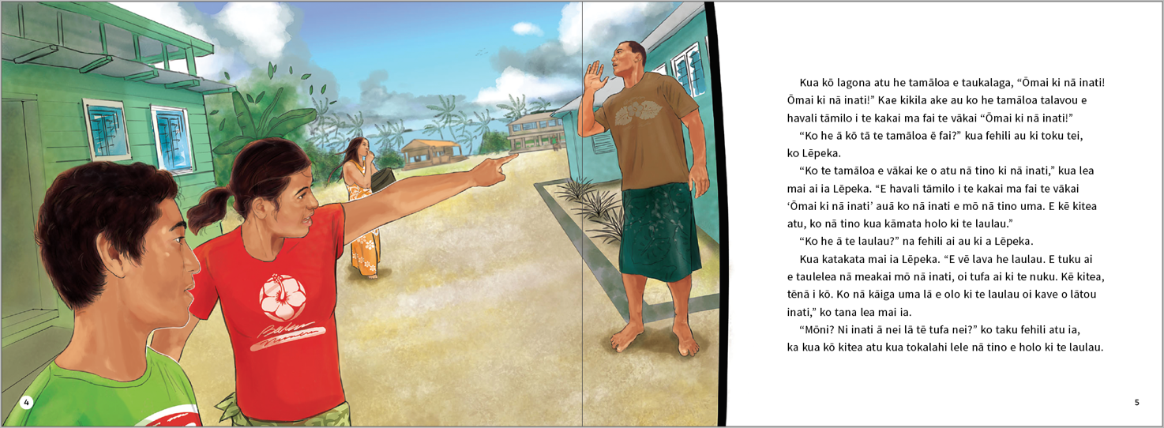
The above page:
Text and illustration copyright © Crown
The above page:
Text and illustration copyright © Crown
page 6
“It’s fish. It’s really windy today. All the men were net fishing early this morning,” Lēpeka said. “They caught a lot of fish. Come on, Hione, let’s go and get our share of the inati,” said Lēpeka.
“Fresh fish! Yum!” I said to Lēpeka. “OK, let’s go. I want to watch how they do the inati.”
“Hione, please help me carry this container for collecting our inati,” Lēpeka said.
I helped Lēpeka carry the container and we walked towards the laulau. We joined the people walking that way.
“Look! ” said Lēpeka. “People can take any container they like to collect their inati. It can be a basket, bowl, or a plastic container,” Lēpeka explained.
page 9
We came to the laulau. “Wow! Look at all the fish!” I said. I heard a man calling “Hamuelu! Hamuelu!” I looked around. I saw a man walking around calling out Hamuelu’s name. “Lēpeka, why is that man calling ‘Hamuelu’?” I asked.
“That man is the tauvāega. He shares out the inati for each family. One family has the name Hamuelu. They use that name when they come to get their share of the inati,” answered Lēpeka. “See that boy running with the basket to the tauvāega? He’s from the Hamuelu family. He’s going to collect his family’s inati,” Lēpeka explained.
“Lēpeka, is that why the fish are grouped that way?” I asked.
“Yes, it is,” agreed Lēpeka. “The tauvāega has shared out the fish, with enough for each family. See that paper the tauvāega is holding? That’s the list of all the families living in Fakaofo. All the families get a share of the inati,” Lēpeka explained.
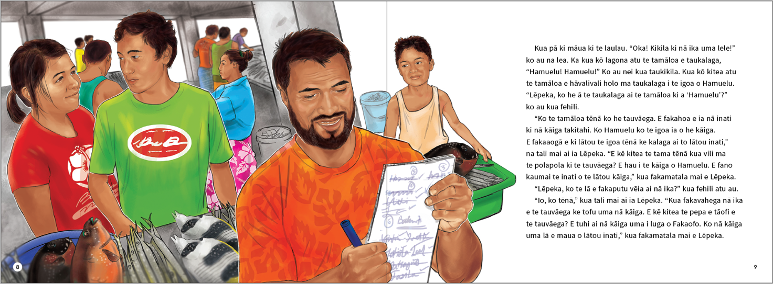
The above page:
Text and illustration copyright © Crown
page 10
“Hey! Lēpeka, look! Some portions of fish are much bigger than others. Why is that?” I asked Lēpeka.
“That’s right. The inati is shared out according to the numbers of people in each family. Remember, some families have more people than others,” Lēpeka told me.
“How many people in our family? Umm, there are eight of us.” I was counting the number of people in our family in my head.
“Hani! Hani!” The tauvāega was calling out this name. I saw a little girl walking towards the tauvāega with a bowl.
“Hione! Hione!” the tauvāega was calling out. I was surprised to hear my name called out. I looked at Lēpeka and she smiled back at me.
“Hione, the tauvāega is calling you. Go and collect our inati,” Lēpeka said.
I walked over to the tauvāega with my container.
page 12
“Hello, Hione!” the tauvāega said, and he put the fish into my container. Everyone looked at me.
I walked back to Lēpeka. I was very proud that my name had been called out.
“That was awesome! I was surprised to hear my name called for our family’s share!” I said
to Lēpeka.
Lēpeka laughed. “I knew you’d be surprised,” she said.
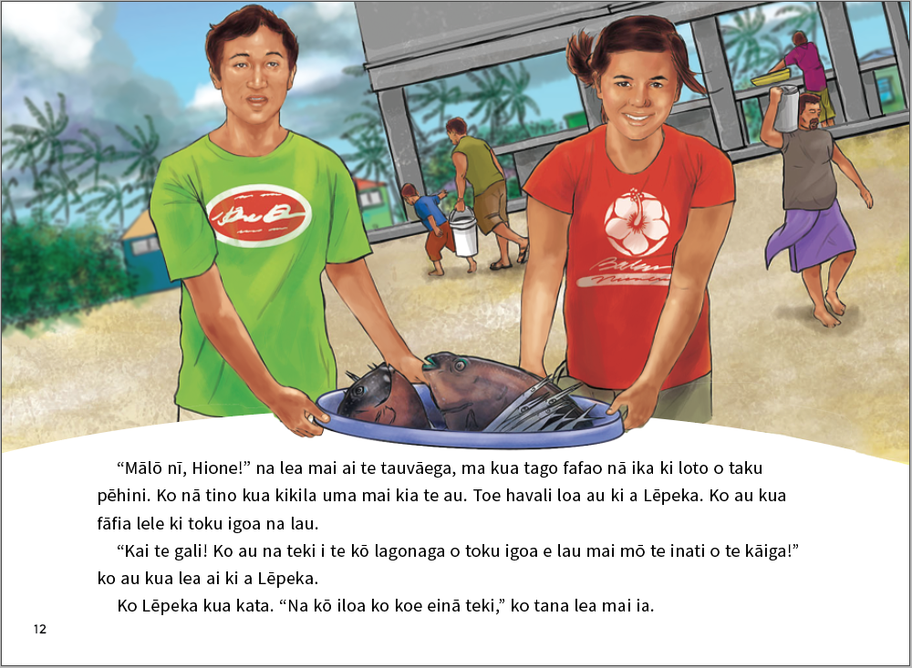
ISBN 978-1-77669-698-7 (WORD)
ISBN 978-1-77669-699-4 (PDF)
The above page:
Text and illustration copyright © Crown

Newton, J., Yates, E., Shearn, S., and Nowitzki, W. (2009). Intercultural Communicative Language Teaching: Implications for Effective Teaching and Learning. Wellington: Ministry of Education.

